swisscansat
CanSat competition for swiss high schools
Application Form : 2022-2023
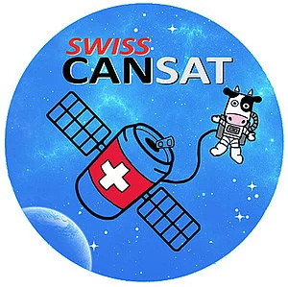

Presented by HES-SO, Issue 2

swisscansat -Application form : 2022-2023
The completed application form has to be sent via the section “Contact Us” on the website www.swisscansat.ch. In case of problem with the uploading the application on the website, you could email the completed application to the following address: swisscansat@hes-so.ch.
Contact details
Team name
Students’ names, ages and dates of birth | 1:  2:  3:  4:  5:  6:  Maximal student number: 6
Contact for communication with organisers | Name:  Phone:  E-mail:
Teacher/tutor from the team’s institution | Name:  Phone:  E-mail:
Teacher/tutor from the HE/HES | - We have a teacher/tutor from the HE/HES for our team:  - Name:  - Phone:  - E-mail:  - We do not have a teacher/tutor from the HE/HES for our team yet. In this case, a teacher will be assigned to you by the organisers.
School name and town/city | Name:  Location:

Organisation
How will you distribute the work among the team members? Consider all aspects of your experiment (structure, parachute, power, software, communications, data analysis)
Do you have access to a workshop or a laboratory?
How much time will your team have available to work on your CanSat, and how will you spend it?
How does your team plan to finance its expenses? Are you supported by your school or other sponsors?
Do you have all the material and equipment needed for your mission? If not, how do you plan to obtain it? Do you require assistance in obtaining any equipment?
Are you going to use the CanSat kit for primary mission? | - Probably yes.  - Probably no.

Scientific mission
What is the secondary mission that you have chosen for your CanSat?
Outline the scientific or technical objective of your secondary mission, and highlight any innovative aspects.
Where did you get the idea from? e.g. from a real satellite mission, another CanSat project, a scientific publication, a book, etc.
Describe your secondary mission in detail. This part should link the scientific objective to the experiment itself. Explain how in practice you are going to fulfil the scientific goal.
Which data will you measure, and how?
What do you plan to do with your results after the flight?

Outreach programme
Describe your Educational Outreach Programme for before and after the CanSat launch campaign, e.g. newspaper articles, local radio, website, presentations at schools, etc.
Which are the social networks where your project will appear? | - Facebook  - LinkedIn  - Twitter  - Other? Please, specify:

- For the competition’s legal notes, please refer to the SwissCanSat guidelines.
- Your personal data are collected and processed by the SwissCanSat organizers in order to enable them to evaluate your application. You have a right of access to your personal data and you can also request the correction or deletion of your personal data. You have the right to oppose the processing of your personal data or to request a limitation of such processing. If you have a request or complaint, please, send either a message to the section “Contact Us” on the website www.swisscansat.ch, or send an email to swisscansat@hes-so.ch

