Proposal acronym
Proposal title
Researcher in charge
School(s) responsible
Date

InnoEnergy thematic field(s) addressed
- [e.g. Energy storage]
- [e.g. Renewable energies]

Technology Readiness Level
At the start of the project |  | At the end of the project

Proposal idea and objectives (approx. 15 lines)
The aim of this project is…

The particular objectives are…

Background to the project (approx. 10 lines)
[Maximum 5 lines indicating what the project is about].

Results (approx. 10 lines)
[list and briefly describe the direct outcomes (e.g. products, services) of the project].

Users (approx. 10 lines)
[Indicate the target audience for the project; e.g. stakeholders and end-users].

Consortium
Name of partner | Country | Role in the project

Phases of the work
- [e.g. Feasibility study of …]
- [e.g. Testing of …]
- [e.g. Marketing of …]

Duration of the project: XX years

Budget (approximate)
 | All partners | HES-SO
Complementary funding
Co-funding |  | (1)
EIT funding
Total cost of the action

- Provided by the school(s) hosting the project

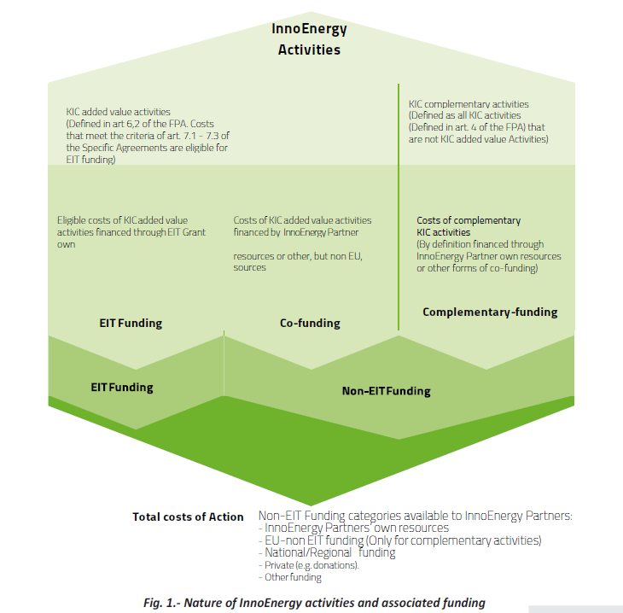
Source: Investment Round 2018.

Compliance with eligibility criteria (2018):

